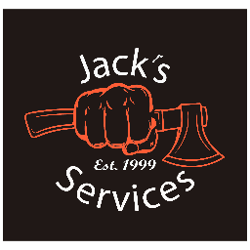
Dumpster Agreement
- Dumpsters can be very heavy, even when empty. An empty 30 yard dumpster weighs approximately 4 tons. They have steel rollers that assist with loading and unloading. Any size dumpster will sink into soft ground, therefore cans are to be kept on hard surfaces.
- If you are concerned about damage, we suggest placing something down for support such as plywood. Jack’s Services Inc is not responsible for any damages done to property.
- Dumpsters are to be filled so cover can be closed while transported. Do NOT fill past the top edge.
- Dumpsters are not to be moved once placed by Jack’s Services Inc. Dumpster will not be removed from site until requested by customer.
- Customer must be accept full responsibility for contents of dumpster and agree to additional charges if the dumpster contains unacceptable items or exceed the allotted weigh limit for the rental. The following items will cost an additional charge if placed in dumpster:

Mattress: $75 Appliance: $50
Truck Tire: $75 Car Tire: $50
Cylinders: $75 Sofa/ Furniture: $75

- We will NOT accept the following:
Animal Waste/ Dead animals
Asbestos
Large amounts of household waste
Liquid waste of any type
Contaminated soil
Hazardous, chemical or medical waste

- Customer is responsible for any damage done to dumpster while in customer’s possession

- Dumpster Cost: Cost varies by size dumpster and allotted tonnage. Payment must be made prior to delivery. New customers must pay with credit card. Returning customers may have an option to pay by check, cash or credit card at the discretion of Jack’s Services Inc. Each additional ton over the allotted tonnage will be charged at a rate of $85/ton. Weight tickets will be provided if requested. Rental includes 15 calendar days at site. $10/day will be charged after 15 days. Any additional charges will be charged to credit card after dumpster has been unloaded and charges calculated.

- By renting a dumpster with Jack’s Services Inc, client agrees to all terms and conditions outlined above

