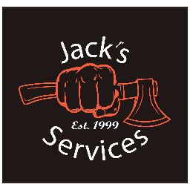
Dumpster Agreement
- Dumpsters can be very heavy, even when empty. They have steel rollers that assist with loading and unloading. Any size dumpster will sink into soft ground, therefore cans are to be kept on hard surfaces.
- If you are concerned about damage, we suggest placing something down for support such as plywood. Jack’s Services Inc is not responsible for any damages done to property.
- Dumpsters to be filled so cover can be closed while transported. Do NOT fill past the FILL LINE.
- Dumpsters are not to be moved once placed by Jack’s Services Inc. Dumpster will not be removed from site until requested by customer.
- Customer must be accept full responsibility for contents of dumpster and agree to additional charges if the dumpster contains unacceptable items or exceed the allotted weigh limit for the rental. The following items will cost an additional charge if placed in dumpster:

Mattress: $110 Appliance: $75
Truck Tire: $85 Car Tire: $75
Cylinders: $85 Sofa/ Furniture: $110

- We will NOT accept the following:
Animal Waste/ Dead animals
Asbestos
Liquid waste of any type
Contaminated soil

- Customer is responsible for any damage done to dumpster while in customer’s possession

- Dumpster Cost: _______ yard dumpster- $________. Allotted tonnage- _____ tons

- Each additional ton over the allotted tonnage will be charged at a rate of $85/ton.

- Payment must be made prior to delivery. New customers must pay with credit card or cash. Rental includes 15 calendar days at site. $10/day will be charged after 10 days. Any additional charges will be charged to credit card after dumpster has been unloaded and charges calculated.

- By renting a dumpster with Jack’s Services Inc, client agrees to all terms and conditions outlined above

